Linux Assignment-1

Name: Aduita Srivastava

Roll no.: 2501730206

Class: B.Tech CSE (AI ML) – A

Introduction
The purpose of this assignment is to gain practical experience with the Linux operating system, the command-line environment, and basic shell scripting.
Linux is widely used across servers, cloud platforms, cybersecurity, networking, DevOps, and software development, which makes it an essential skill for IT professionals and computer science students. By learning how to navigate the Linux file system, manage files and directories, monitor processes, and use networking tools, students develop a strong foundation for working with real-world systems.
Another key part of this assignment is learning shell scripting. Shell scripts allow users to automate tasks, improve efficiency, and perform system operations consistently and reliably. Through writing scripts for backup operations, system monitoring, and automated downloading, this assignment demonstrates how automation can simplify complex workflows.
Overall, this work helps build confidence in using the Linux terminal and prepares students for more advanced system administration and programming tasks.

Installation:
I downloaded mine from Microsoft Store.
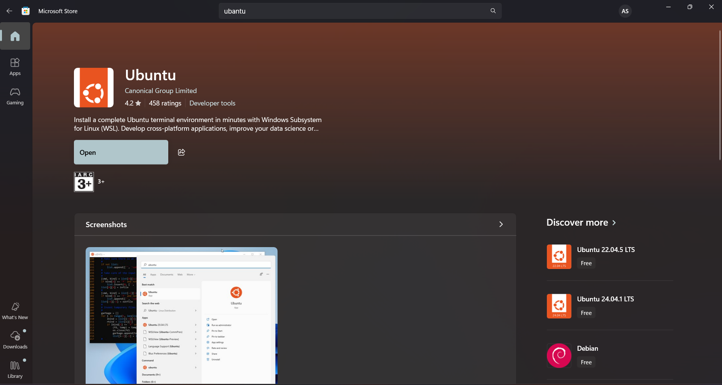
Commands:
Used:
Ls, pwd, cd , tree, mkdir, echo, nano, cp, mv, chmod, chown, ps, top, kill, ping, history, clear.
Screen shots:
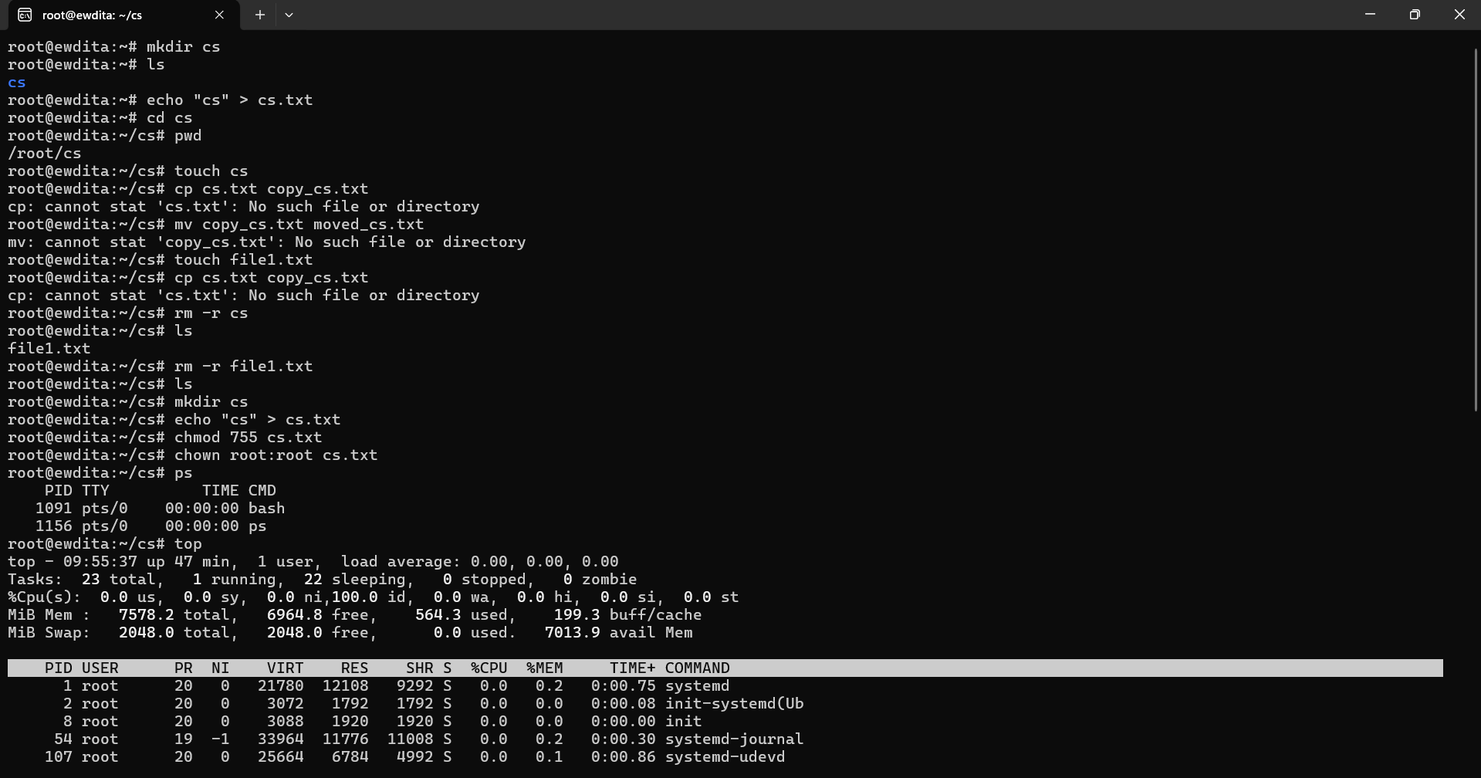
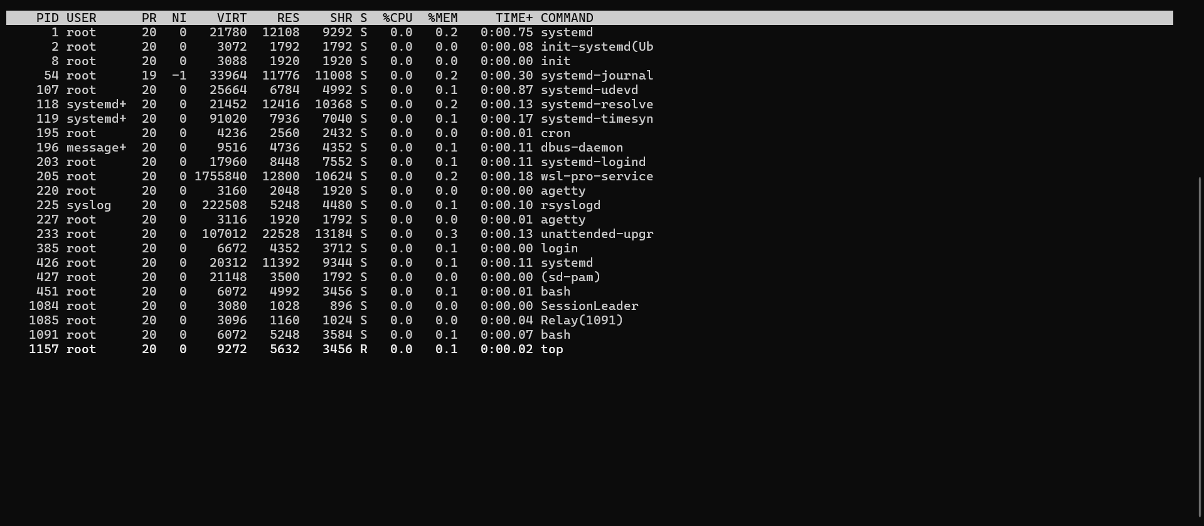
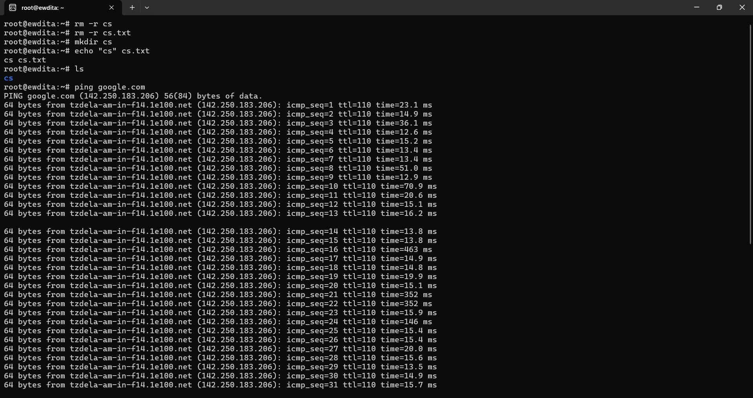

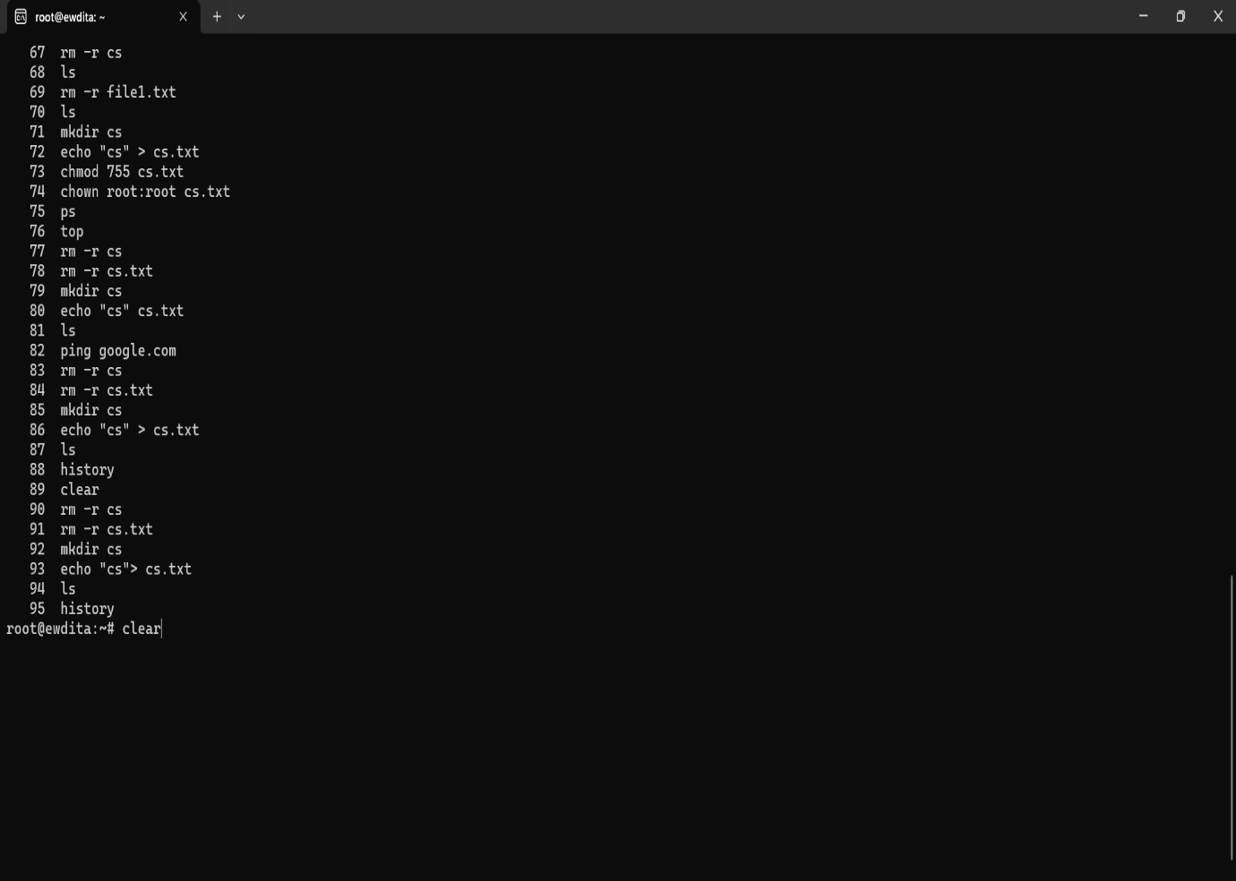
Shell Scripting:
- Backup script
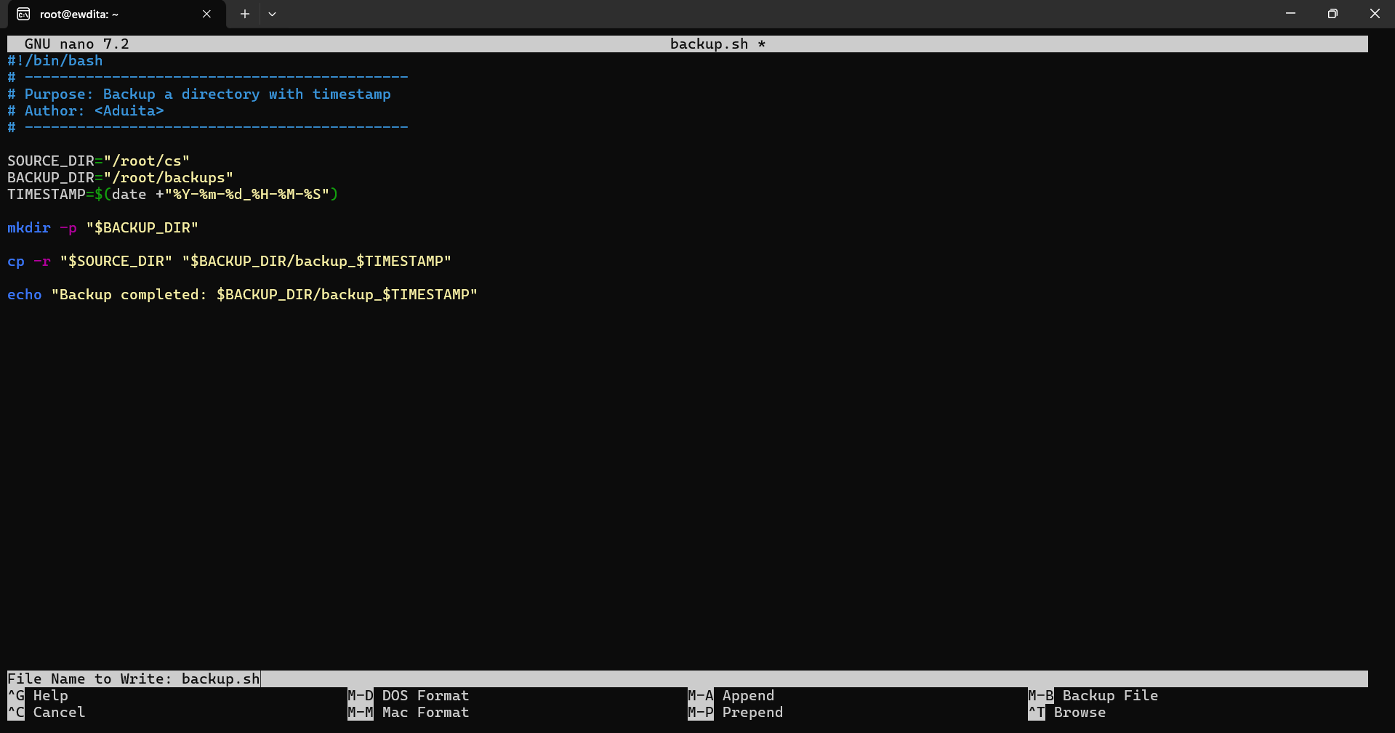

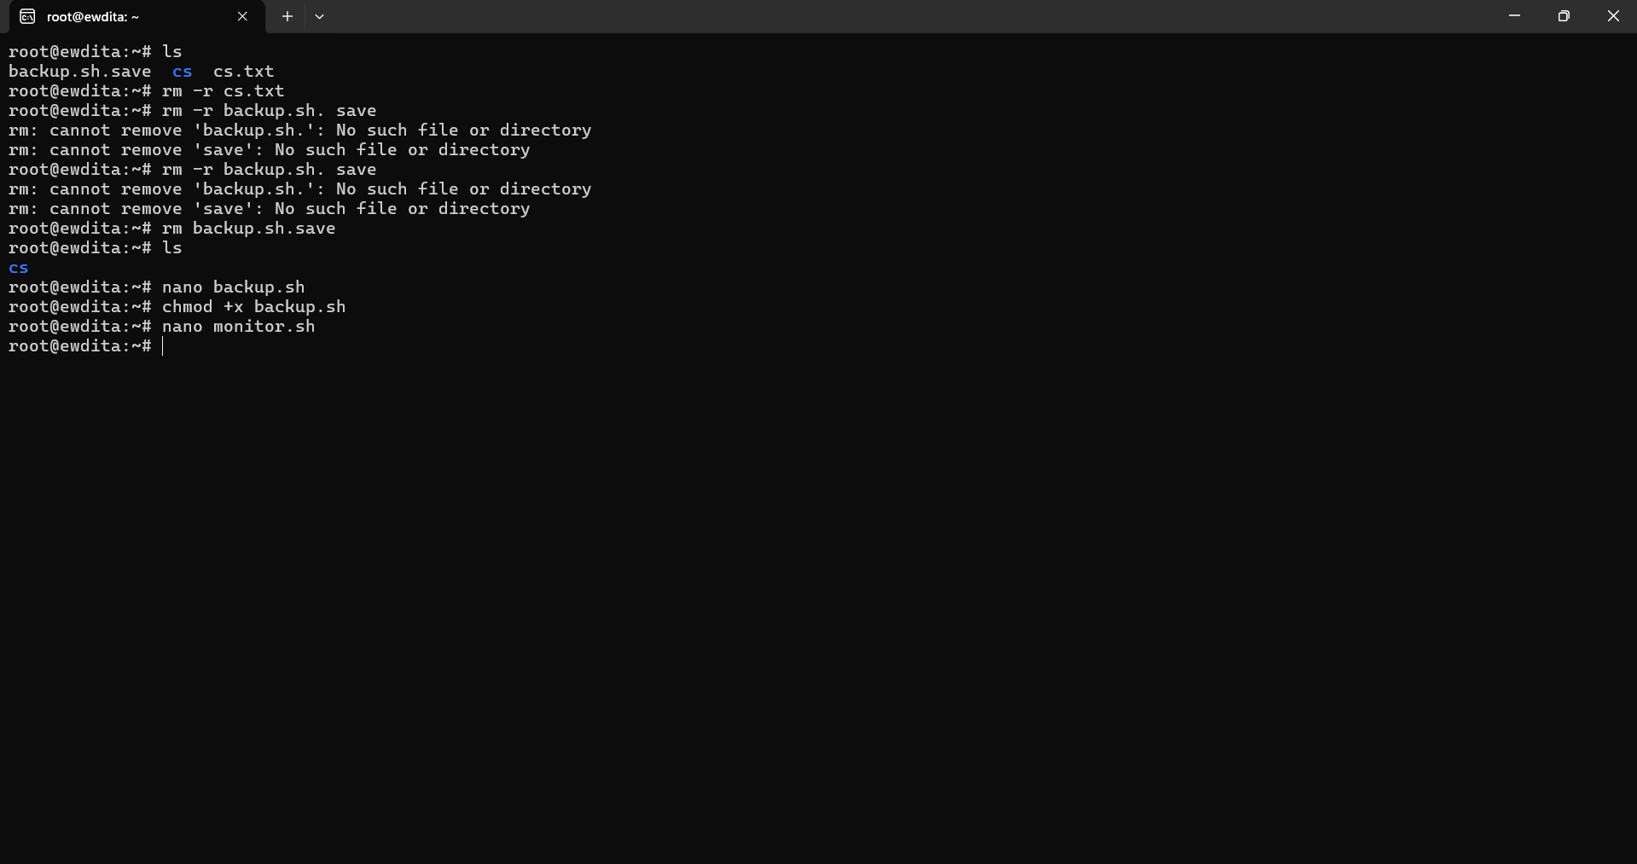
2.Memory monitoring script:

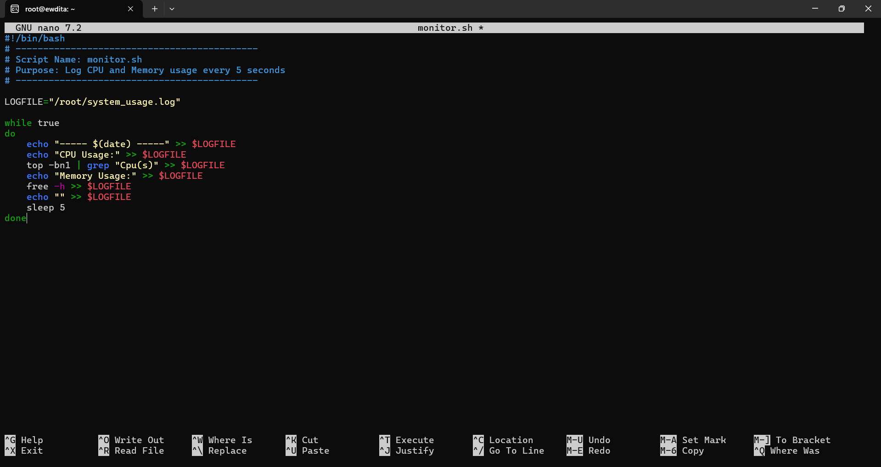

- Download script
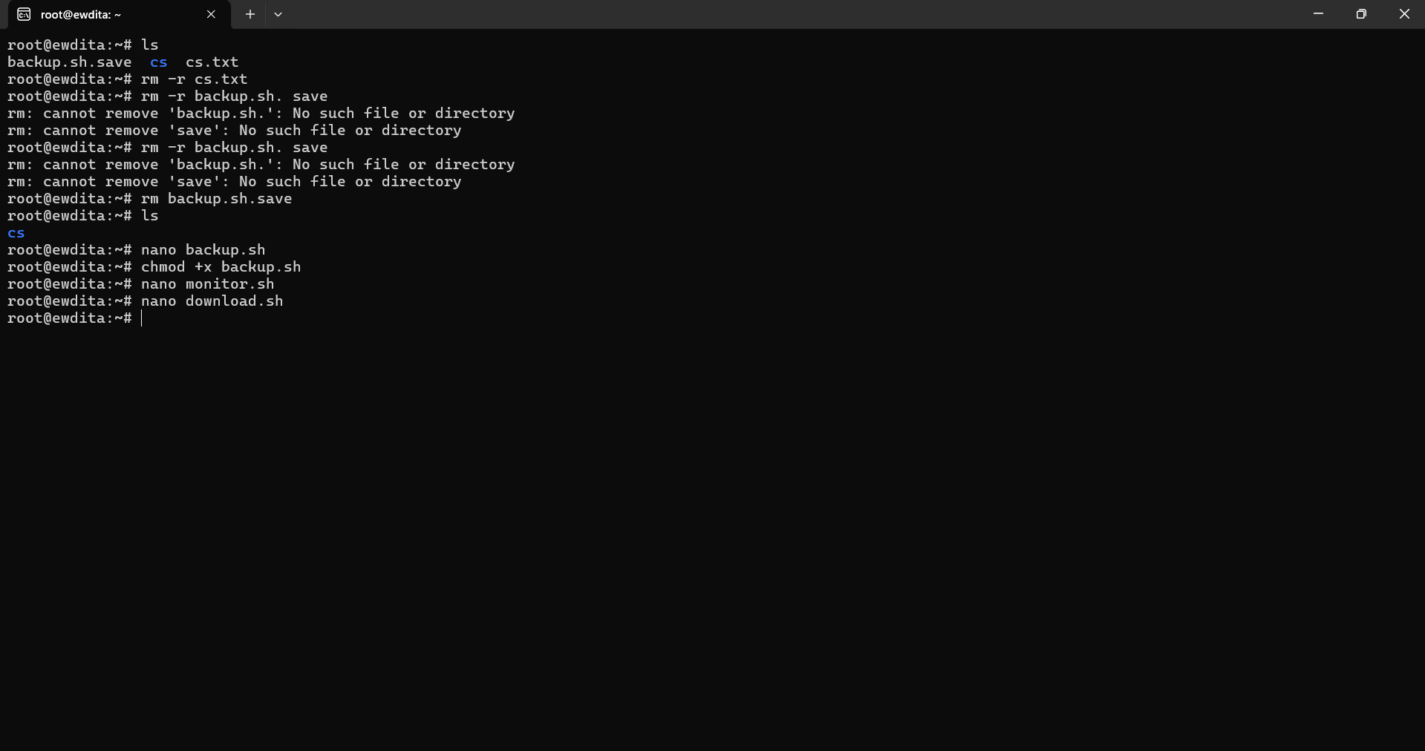

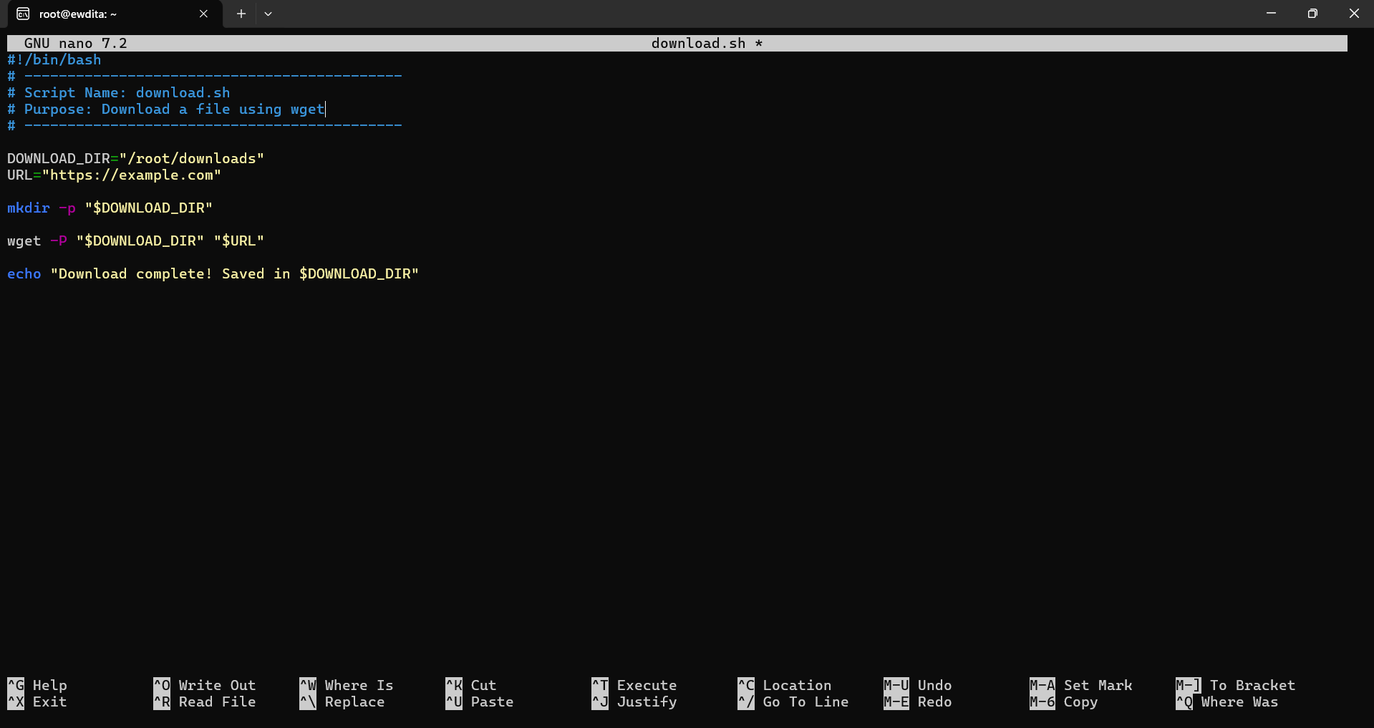

Reflections:
Completing this assignment helped me become more comfortable with Linux, WSL, and shell scripting, but it did have a few obstacles. One of the first obstacles I saw was grasping how Linux handles file paths and directories. It was simple errors such as forgetting a capital letter, not typing the exact folder name, or accidentally typing a character such as < that caused me errors. This taught me a lesson about how borderline strict Linux is in comparison to graphical interfaces. Secondly, I also struggled with using the Nano text editor. Grasping the use of it especially around command usage, saving, editing, and name properly naming the script files was challenging for me. I learned to confirm and double-check what I had typed if I accidently created a file with the wrong extension or if I deleted the wrong file.
Learning how to shell script was another learning curve. Being able to make a file executable using chmod, the importance of the shebang (#!/bin/bash) header, and then working with variables and timestamps required high-level thinking about each little detail. Debugging all the scripts for example with the backup automation and the system monitoring loop, so much fun learning how Linux would process commands, be it via direct execution of the commands themselves or in script form.

Overall though, the learning outcomes were terrific from an education standpoint despite the challenges. I have some understanding now of to complete commands to manage files and directories, permissions, network tools, and running processes from the terminal directly.

